Cameroon

## Freedom House political status

The data set shows the Freedom House political scores and status of the country each year.

## # A tibble: 19 x 5  
## country iso3c date mean status   
## <chr> <chr> <dbl> <dbl> <chr>   
## 1 Cameroon CMR 1996 6 Not Free  
## 2 Cameroon CMR 1998 6 Not Free  
## 3 Cameroon CMR 2000 6.5 Not Free  
## 4 Cameroon CMR 2002 6 Not Free  
## 5 Cameroon CMR 2003 6 Not Free  
## 6 Cameroon CMR 2004 6 Not Free  
## 7 Cameroon CMR 2005 6 Not Free  
## 8 Cameroon CMR 2006 6 Not Free  
## 9 Cameroon CMR 2007 6 Not Free  
## 10 Cameroon CMR 2008 6 Not Free  
## 11 Cameroon CMR 2009 6 Not Free  
## 12 Cameroon CMR 2010 6 Not Free  
## 13 Cameroon CMR 2011 6 Not Free  
## 14 Cameroon CMR 2012 6 Not Free  
## 15 Cameroon CMR 2013 6 Not Free  
## 16 Cameroon CMR 2014 6 Not Free  
## 17 Cameroon CMR 2015 6 Not Free  
## 18 Cameroon CMR 2016 6 Not Free  
## 19 Cameroon CMR 2017 6 Not Free

## Freedom House classification of political change

The data set shows the GDP growth and the ecomic growth classification of the country each year.

## # A tibble: 19 x 4  
## country iso3c date politicalChangeFH  
## <chr> <chr> <dbl> <chr>   
## 1 Cameroon CMR 1996 no change   
## 2 Cameroon CMR 1998 no change   
## 3 Cameroon CMR 2000 no change   
## 4 Cameroon CMR 2002 no change   
## 5 Cameroon CMR 2003 no change   
## 6 Cameroon CMR 2004 no change   
## 7 Cameroon CMR 2005 no change   
## 8 Cameroon CMR 2006 no change   
## 9 Cameroon CMR 2007 no change   
## 10 Cameroon CMR 2008 no change   
## 11 Cameroon CMR 2009 no change   
## 12 Cameroon CMR 2010 no change   
## 13 Cameroon CMR 2011 no change   
## 14 Cameroon CMR 2012 no change   
## 15 Cameroon CMR 2013 no change   
## 16 Cameroon CMR 2014 no change   
## 17 Cameroon CMR 2015 no change   
## 18 Cameroon CMR 2016 no change   
## 19 Cameroon CMR 2017 no change

## Freedom House score trend

The plot shows the Freedom House scores trend of the country.

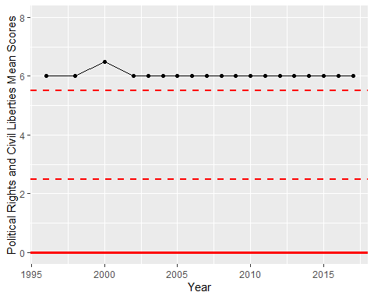

Freedom House Score Trend